1. Extract ios.zip to “C:\wamp\www”

In “www” folder, there should be “ios” folder. And when you open “ios” folder, it should contain these files:

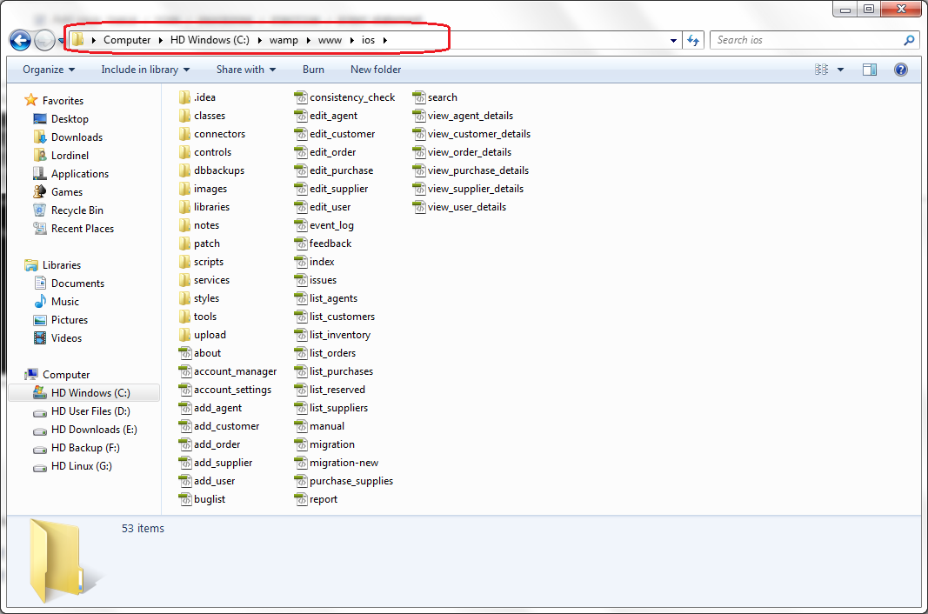

2. Open Firefox and go to “http://localhost/phpmyadmin”

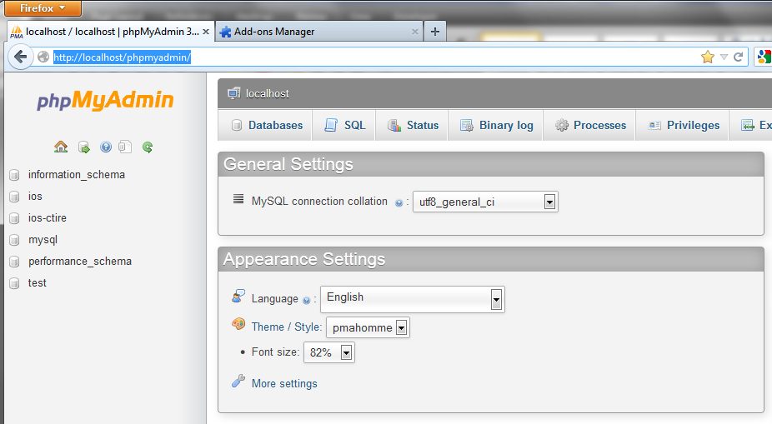

3. Delete existing database (if any).

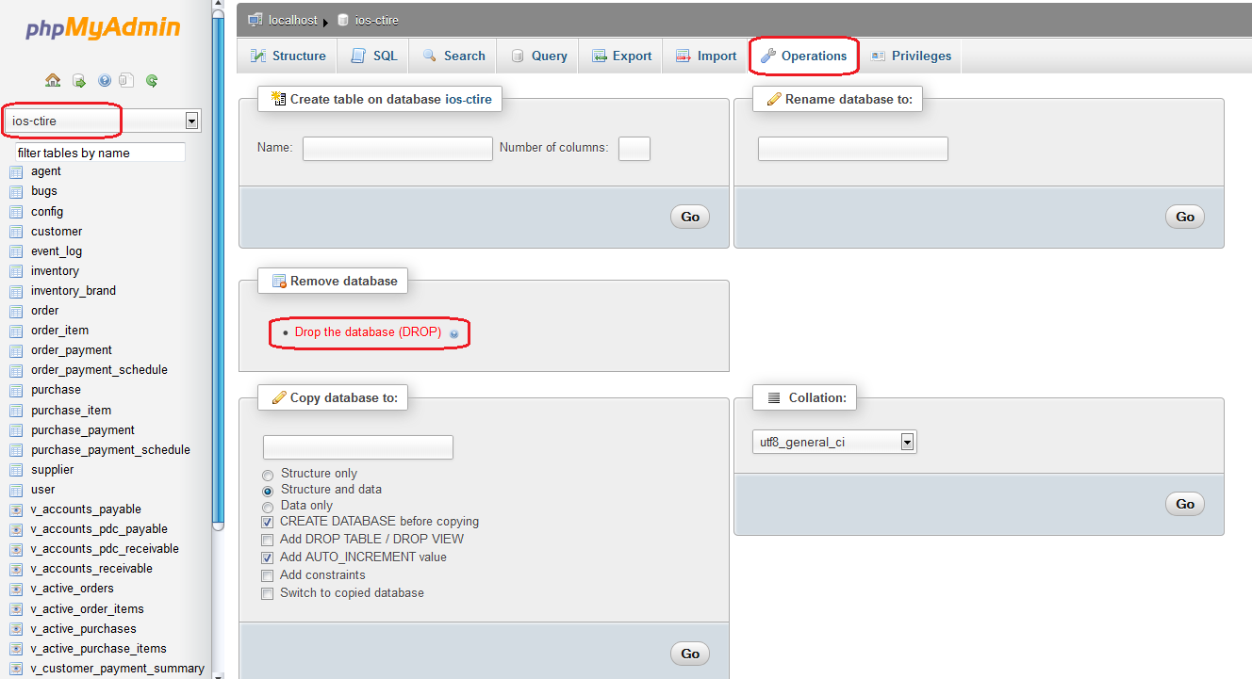

4. Create new database named “ios-ctire” with collation “utf8_general_ci”.

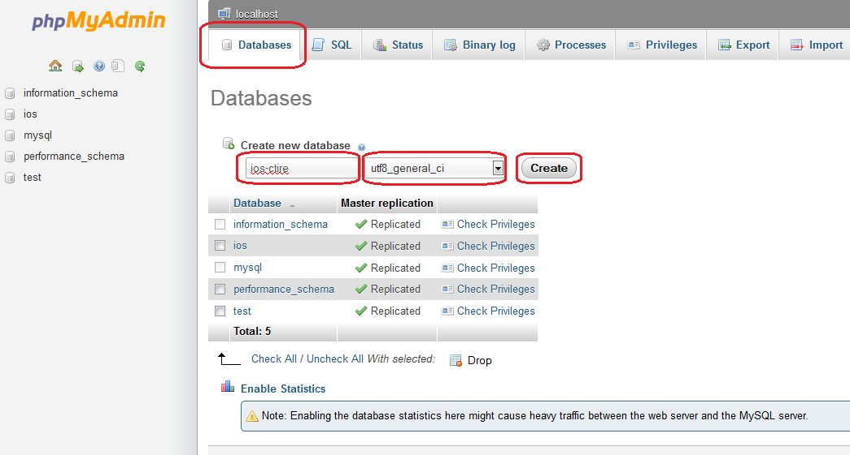

5.